Git commands and workspace:
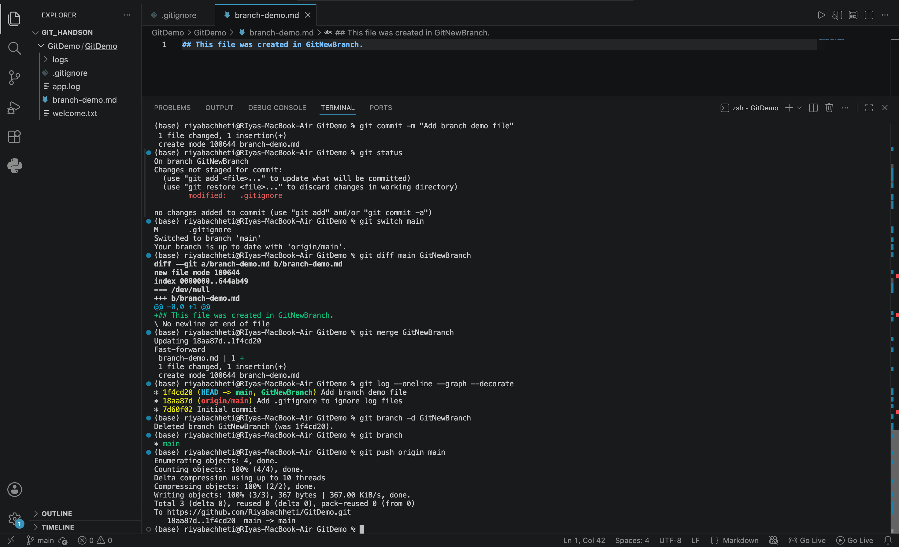

git repo:
